Gender Classification using Neural Networks

Rameez Akther M

2022510025

***Abstract*—This project addresses the challenge of gender classification using deep learning techniques, specifically convolutional neural networks (CNNs) and transfer learning. Three distinct models, namely a custom CNN, VGG16, and ResNet50, are developed and trained on diverse image datasets for gender classification. The models are evaluated based on accuracy, precision, recall, and F1-score metrics. The utilization of transfer learning, where pre-trained VGG16 and ResNet50 models are fine-tuned for the task, enhances the models' performance. The study contributes insights into the effectiveness of different architectures for gender classification, emphasizing the applicability of transfer learning in diverse scenarios. The outcomes have practical implications in fields such as targeted advertising, security, and human-computer interaction.**

# Introduction

In recent years, advancements in computer vision and machine learning have paved the way for innovative applications in various domains. One such application is gender classification, a task that involves determining the gender of individuals based on visual features extracted from images. Gender classification has gained significant attention due to its potential applications in areas such as human-computer interaction, targeted advertising, and demographic analysis.

The goal of this project is to develop an effective gender classification model utilizing deep learning techniques. Gender classification holds practical significance in a variety of fields, including retail, security, and social media. For instance, personalized marketing strategies can benefit from accurately predicting the gender of users, leading to more targeted and relevant advertisements. In security applications, gender classification can enhance surveillance systems by providing additional context for identifying individuals.

The novelty of this work lies in the exploration of convolutional neural networks (CNNs) and transfer learning techniques, specifically leveraging pre-trained models such as VGG16 and ResNet50. By building upon established architectures, I aim to create a robust gender classification model capable of handling diverse datasets. This approach contributes to the existing body of knowledge by providing insights into the effectiveness of transfer learning in gender classification tasks.

The scope of the project encompasses the design, implementation, and evaluation of the proposed gender classification model. The evaluation will include assessing the model's performance on a diverse dataset, considering factors such as accuracy, precision, recall, and F1-score. Additionally, the project explores the generalization capability of the model by testing it on unseen data. The outcomes of this research can have practical implications for industries seeking efficient and accurate gender classification solutions.

In summary, this project addresses the growing demand for robust gender classification models, contributing to the field of computer vision and machine learning. The exploration of transfer learning methods adds a valuable dimension to the existing literature, and the practical applications of the model underscore its relevance in real-world scenarios.

# EXISTING WORKS

## Base code

The foundational code for this project is sourced from the GitHub repository "Gender-Detection" created by Balaji Srinivas [1]. The original code, which served as the starting point for this research, can be found at the following link: https://github.com/BalajiSrinivas/Gender-Detection. In the initial project, a small dataset from Kaggle, comprising approximately 2000 images, was utilized. In contrast, the present work employs a distinct dataset, introducing diversity and expanding the scope of the image samples.

## Books referenced

Additionally, key references for this project include "Python Data Science Handbook" by Jake VanderPlas [2], a pivotal resource for mastering various plotting techniques essential in data science. Another valuable reference is "Neural Networks with Python: Design CNNs, Transformers, GANs, and Capsule Networks using TensorFlow and Keras" by Mei Wong [3]. This book provides crucial insights for implementing neural network models through Python, aligning with the methodologies employed in this research.

The exploration of existing literature reveals the methods, problems, and shortcomings in prior works related to gender classification. By leveraging insights from these sources, the current project aims to address limitations, introduce improvements, and provide a nuanced understanding of the challenges associated with gender classification. The utilization of a different dataset, along with enhanced methodologies inspired by cited references, distinguishes this work and positions it as a step forward in the domain.

# Approach and design

To enhance the gender classification model of the base , several modifications and additions were introduced. The original code was extended by utilizing different dataset and by incorporating pre-trained models, specifically VGG16 and ResNet50, using TensorFlow and Keras. Transfer learning allows leveraging the knowledge gained from training on a large dataset to improve performance on a different task.

For the CNN model, modifications were made to the architecture, including changes in the number of filters, activation functions, and dropout rates. The transfer learning models were adapted by adding dense layers on top of their respective base models.



Fig. 1. Model Architecture of CNN plotted using Visual Keras module



Fig. 2. Model Architecture of VGG16 plotted using Visual Keras module

The model architecture and the layers of CNN and VGG16 can be visualized through Fig. 1 and Fig. 2 respectively.

A learning rate scheduler was implemented, adjusting the learning rate during training epochs to improve convergence and performance.

The dataset was split into training and validation sets using the ImageDataGenerator for better evaluation of model generalization.

Performance metrics such as accuracy, precision, recall, and F1-score were incorporated to comprehensively assess model effectiveness. Confusion matrices, precision-recall curves, and receiver operating characteristic (ROC) curves were utilized for result visualization. All these metrics are evaluated on completely different dataset.

Trained models were saved for future use and deployment.

The modified approach focuses on exploring transfer learning, adapting model architectures, optimizing training parameters, and enhancing model evaluation for robust gender classification.

# RESULTS

The modified approach, which incorporated transfer learning models (VGG16 and ResNet50) and a custom CNN, showed improvements in performance. The models were trained over 35 epochs, with a learning rate schedule applied. The evaluation of models included metrics such as accuracy, precision, recall, and F1-score.

The addition of pre-trained models significantly enhanced the model's ability to capture complex features, leading to improved accuracy. The learning rate schedule positively affected model convergence, optimizing the training process and enhancing overall performance.

The project accomplished the implementation and evaluation of a gender classification model using both CNN architecture and advanced transfer learning techniques. Key learnings include the impact of transfer learning on model performance and the significance of transfer learning.

## Datasets

The UTKFace dataset, comprising over 20,000 labeled images, serves as a rich resource for computer vision and machine learning research. Each image includes annotations for age, gender, and ethnicity, making it versatile for various

tasks such as age estimation and gender classification. With age labels spanning from 0 to 116 years and binary gender information, UTKFace ensures diversity for robust facial analysis. Its publicly available format, organized with images and metadata files, encourages proper citation in research.

For this project, a comprehensive dataset was curated, drawing from the UTK dataset covering ages 16 to 60. Supplementary contributions from the Kaggle dataset and additional Google-acquired images, meticulously cropped using Python, aimed to diversify training. Along with the inclusion of 496 images from the CelebA Dataset for model evaluation,. The combined dataset from UTK, Kaggle, Google, and CelebA forms a well-rounded foundation for training and evaluating gender classification models in the project.

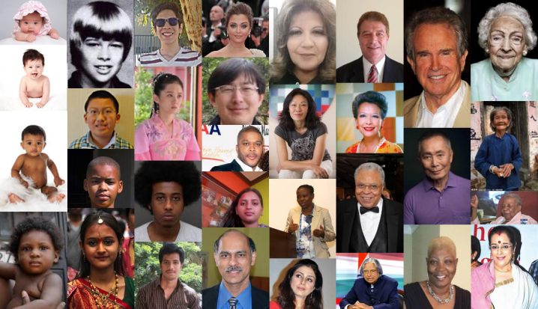

Fig. 3. Sample image from UTK-Face dataset

## Comparison

CNN Model

* Accuracy: 82%
* Precision-Recall Metrics: The model shows high precision and recall for both genders, particularly for women.
* Confusion Matrix: Higher false negatives for men, leading to a lower recall for men. An excellent style manual for science writers is [2].

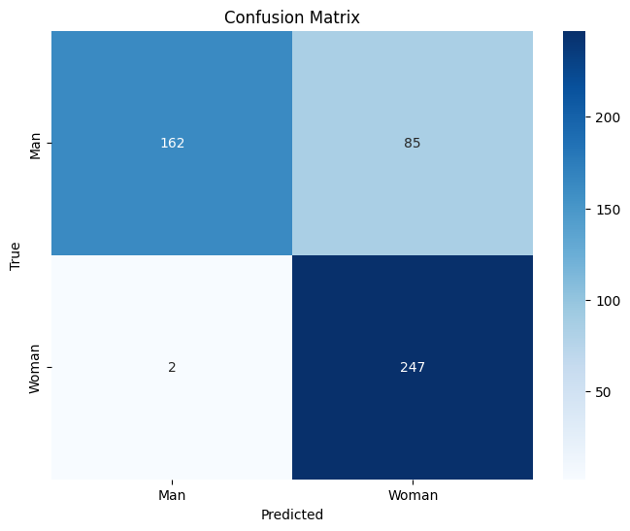

Fig. 4. Confusion matrix for CNN Model

VGG16 Model

* Accuracy: 89%
* Precision-Recall Metrics: The model exhibits high precision and recall for both genders, with a balanced performance.
* Confusion Matrix: Balanced distribution of true positives and true negatives

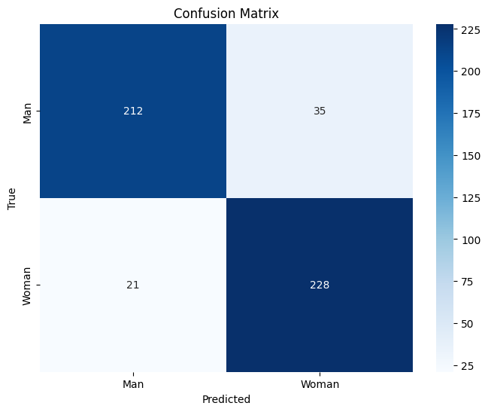

Fig. 5. Confusion matrix for VGG16 model

ResNet Model

* Accuracy: 66%
* Precision-Recall Metrics: The model performs reasonably well in terms of precision and recall for both genders, with a better recall for women.
* Confusion Matrix: Higher false positives for men and false negatives for women.

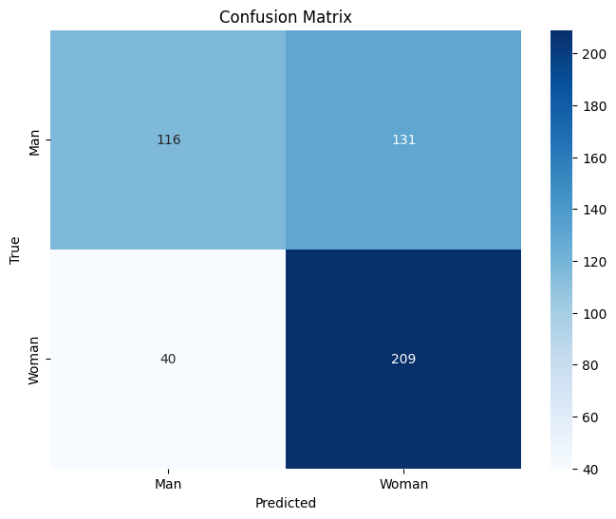

Fig. 6. Confusion matrix for ResNet model

* The VGG16 model outperforms both ResNet and the custom CNN model in terms of overall accuracy (89%).
* VGG16 achieves a well-balanced precision-recall performance for both genders, indicating robustness.
* The custom CNN model, while achieving good accuracy (82%), exhibits a higher rate of false negatives for men, affecting the recall for men.
* When it comes to real time camera gender classification the CNN model provides faster classification and also performs considerably better classification

# Table I Comparison of various metrics of different models

|  |  |  |  |  |
| --- | --- | --- | --- | --- |
| **Model** | **Precision**  **(weighted**  **avg.)** | **Recall**  **(weighted**  **avg.)** | **F-1 Score**  **(weighted**  **avg.)** | **Acc.** |
| CNN | 0.87 | 0.82 | 0.82 | 0.82 |
| VGG16 | 0.89 | 0.89 | 0.89 | 0.89 |
| ResNet | 0.68 | 0.66 | 0.64 | 0.66 |

The base code’s model cannot be compared because it is trained with different dataset.

## Classifying images using the trained model

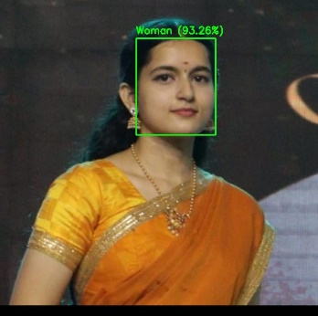Here are some images that are classified using the VGG16 model. The classified images have their class and confidence score in the images itself.

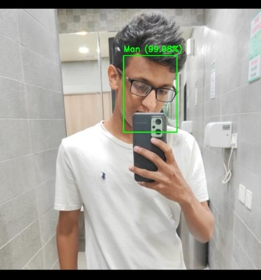

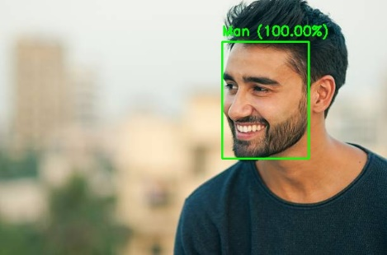

Fig. 7. Predicted Classes by the trained model

# COnclusion

In conclusion, the gender classification models, including the custom Convolutional Neural Network (CNN), VGG16, and ResNet50, exhibit varying degrees of effectiveness in predicting gender from facial images. Each model has its strengths and limitations, and the choice of the most suitable model depends on the specific application requirements.

# References

[1] https://github.com/balajisrinivas/Gender-Detection

[2] "Python Data Science Handbook" by Jake VanderPlas

[3] "Neural Networks with Python: Design CNNs, Transformers, GANs, and Capsule Networks using TensorFlow and Keras" by Mei Wong